Name:

Big Bad Wolf’s Yom Kippur
A Reading and Discussion Guide for Elementary Schools
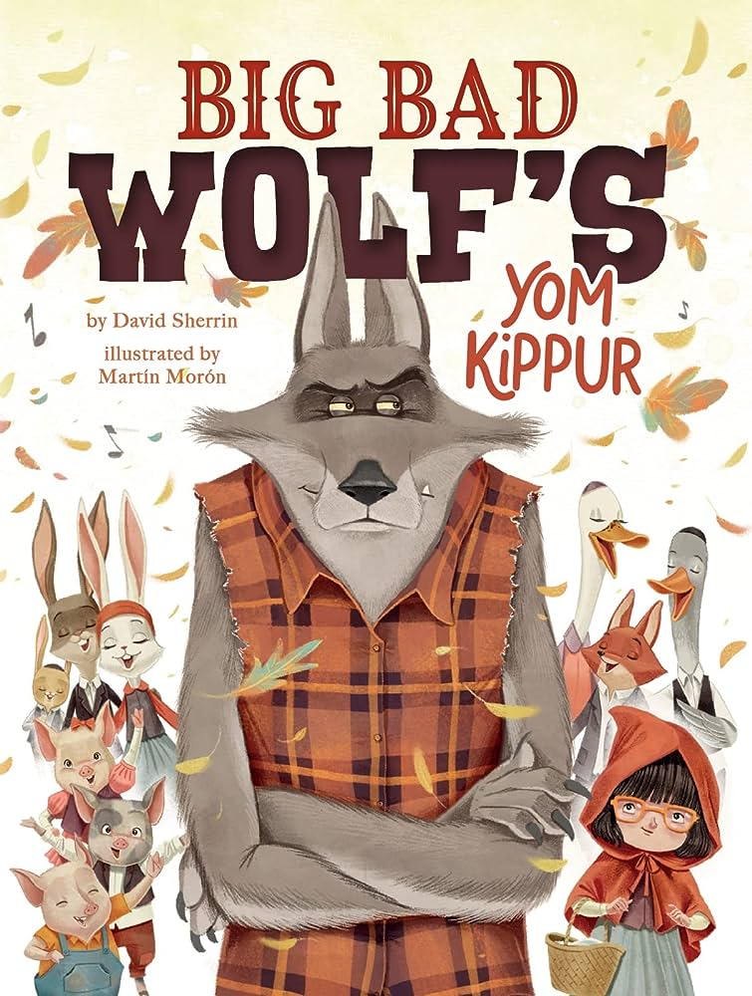
Big Bad Wolf’s Yom Kippur is based around a Jewish holiday called Yom Kippur. This is the most sacred (special) day in the Jewish calendar, in which Jews are supposed to think about ideas like forgiveness, kindness, and becoming a better person and member of the community.

Pre-Reading
Acting! Before reading, imagine you are an animal in the forest like a rabbit or deer. You are peacefully going about your day and then suddenly…the Big Bad Wolf shows up. What would your face look like? How would you respond?

Jewish/Hebrew Terms - Based on the story, match the new word in the story to its meaning.

Hebrew/Jewish word | Meaning
Synagogue  “I’m asking for forgiveness…I’m also going to synagogue” | A Jewish religious leader
Rabbi  “Rabbi Dov talked about how the leaves change colors each fall.” | A Jewish house of worship (like a church or mosque)
Cantor  “Cantor Tzipporah led the animals in song” | The “musical leader” in a synagogue
Shanah Tovah  “Shanah Tovah, Wolf!” | A term of affection for a girl “little mama”
Mamaleh  “Mamaleh, you brought Wolf!” | A greeting on Rosh Hashanah and Yom Kippur. It means “Happy New Year!”
Shofar  “A shofar blasted in the distance.” | A ram’s horn used on Rosh Hashanah and Yom Kippur

After Reading
Discussion: While this is a Jewish themed story, the book also shows universal values that can be found in many other religion’s beliefs and traditions. Here are some examples:

- In Christianity, to forgive someone is important because it helps heal everyone involved.

  - Where do we see forgiveness in the book? Who forgives and how does it heal?

- In Islam, observant Muslims don’t eat or drink during daylight hours during the month of Ramadan. This is called fasting.

  - Where do we see fasting in Big Bad Wolf’s Yom Kippur? Who is not supposed to fast? Why do you think that is?

- Buddhism teaches that people should do Right Action. People can’t just “be kind” in our hearts. We need to do the right action and act kindly in order to be good.

  - Where do we see Right Action in Big Bad Wolf’s Yom Kippur? Who does Right Action?

- Many Hindus believe people have special roles to play in their communities. Who plays a special role in this story?

  - Which characters support the Big Bad Wolf in the story? How? Do you think he could have made his big change alone?

Reflection Activity
The story begins with the Big Bad Wolf making a To Do List. On the list, it says: | At the end of his story, his To Do List looks like this:
- Lie to children  - Eat grandmothers  - Bother neighbors  - Knock down pigs’ houses | - Help Little Red Riding Hood with homework  - Rake Granny’s leaves  - Take Raccoon grocery shopping  - Paint with Three Little Pigs

How does the To Do List change between the beginning and end of the story? Why do you think it changes and what does this represent for the main character?

Now, make your own Good Wolf To Do List. What are four things you can do today to be a “Good Wolf?” Or, draw a picture of what it would look like if you did four kind acts.

“Good Wolf” To Do List (or drawing)

